# Brainstorm

**TIP**

You can select a sticky note and hit the pencil [switch to sketch] icon to start drawing!

**& idea prioritization**

### Use this template in your own brainstorming sessions so your team can unleash their imagination and start shaping concepts even if you're not sitting in the same room.

**10 minutes** to prepare

**1 hour** to collaborate

**2-8 people** recommended

**Before you collaborate**

A little bit of preparation goes a long way with this session. Here’s what you need to do to get going.

**10 minutes**

1. **Team gathering**

Define who should participate in the session and send an invite. Share relevant information or pre-work ahead.

1. **Set the goal**

Think about the problem you'll be focusing on solving in the brainstorming session.

1. **Learn how to use the facilitation tools**

Use the Facilitation Superpowers to run a happy and productive session.

[**Open article**](https://support.mural.co/en/articles/2113740-facilitation-superpowers)

Autonomous Drone Routing.

Detecting smoke with video cameras and algorithms.

**1**

## Define your problem statement

What problem are you trying to solve? Frame your problem as a How Might We statement. This will be the focus of your brainstorm.

**5 minutes**

**PROBLEM**

**How might we [your problem statement]?**

##### Key rules of brainstorming

To run an smooth and productive session

**2**

## Brainstorm

Write down any ideas that come to mind that address your problem statement.

**10 minutes**

**V.PIREVEENKUMAR**

Upon receiving sensor data,the gateway transmits the data back via satellite( in an optimised manner ) to a cloud platform or dashboard.

Detect fire using Temperature Levels

CO2/Temperature sensors are deployed throughout the coverage area.CO2 levels can be monitored every 15 minutes (orless),along with temperature, battery status etc

Heat detectors are the most basic detection devices.They areavailable in several type.These type are spot and line.

The gateway providers LoRaWAN coverage for up to 15KM or more outdoors,providing low power wireless access to the network of sensors

The network can detect fires quickly while consuming energy efficiency.

**R.PRABA**

In preprocessing unwanted distortions are removed and image is resized and transformations of resized image is performed.

#### High frequencies of an image are eliminated using SWT and the reconstruction of image are done by inverse SWT

**3**

**Group ideas**

Take turns sharing your ideas while clustering similar or related notes as you go. Once all sticky notes have been grouped, give each cluster a sentence-like label. If a cluster is bigger than six sticky notes, try and see if you and break it up into smaller sub-groups.

**20 minutes**

Detect fire using Temperature Levels

Detection of forest fire is done through the deployment of YOLOv4 to UAV-

based aerial images.

**4**

## Prioritize

Your team should all be on the same page about what's important moving forward. Place your ideas on this grid to determine which ideas are important and which are feasible.

**20 minutes**

Infrared cameras for early warning fire detection

## After you collaborate

You can export the mural as an image or pdf to share with members of your company who might find it helpful.

##### Quick add-ons

1. **Share the mural**

**Share a view link** to the mural with stakeholders to keep them in the loop about the outcomes of the session.

1. **Export the mural**

Export a copy of the mural as a PNG or PDF to attach to emails, include in slides, or save in your drive.

##### Keep moving forward

**Strategy blueprint**

Define the components of a new idea or strategy.

[**Open the template**](https://app.mural.co/template/e95f612a-f72a-4772-bc48-545aaa04e0c9/984865a6-0a96-4472-a48d-47639307b3ca)

**Customer experience journey map**

Understand customer needs, motivations, and

Stay in topic.

This method involves three steps processing. SWT, histogram analysis.

Defer judgment.

Third, the response time of image processing models is better than that of existing sensor models. Finally the overall cost of image processing systems is lower than existing systems.

The first factor is the rapid development of digital camera technology and CCD or CMOS digital camera which has resulted in a rapid increase in image quality and decreased cost of the cameras.

The second factor is that digital cameras can cover large areas with excellent results.

Sensor technology has been widely used in fire detection usually depending on sensing physical parameters such as changes in pressure, humidity and temperature, as well as chemical parameters such as carbon dioxide, carbon monoxide and nitrogen dioxide.

Encourage wild ideas.

Listen to others.

##### Importance

obstacles for an experience.

[**Open the template**](https://app.mural.co/template/b7114010-3a67-4d63-a51d-6f2cedc9633f/c1b465ab-57af-4624-8faf-ebb312edc0eb)

Detecting smoke with video cameras and algorithms.

Go for volume. If possible, be visual.

Terrestrial Image-Based 3D Modeling.

Infrared cameras for early warning fire detection

**K.KANNAN**

## B.CHANDRU

If each of these tasks could get done without any difficulty or cost, which would have the most positive impact?

**Strengths, weaknesses, opportunities & threats**

Terrestrial Image-Based 3D Modeling.

Identify strengths, weaknesses, opportunities, and threats (SWOT) to develop a plan.

[**Open the template**](https://app.mural.co/template/6a062671-89ee-4b76-9409-2603d8b098be/ca270343-1d54-4952-9d8c-fbc303ffd0f2)

#### Spot detectors are single units installed in single locations throughout the protected area by detecting the forest fires.

By using the MWR infrard cameras can be used to detect heat and with particular algorithms can detect hotspots with in a scene as well as flames for both detection and protection of fire and risks of fire

In recent history and even the present day,several forest fire detection methods have been implemented,such as watchtowers,satellite image processing methods are used.

Forest fire detection uses the technique of optical sensors and digital camera based methods are used to monitored the fires.

[**Share template feedback**](https://muralco.typeform.com/to/CiqaHVat?typeform-source=app.mural.co)

[**Share template feedback**](https://muralco.typeform.com/to/CiqaHVat?typeform-source=app.mural.co)

##### Feasibility

Regardless of their importance, which tasks are more feasible than others? (Cost, time, effort, complexity, etc.)

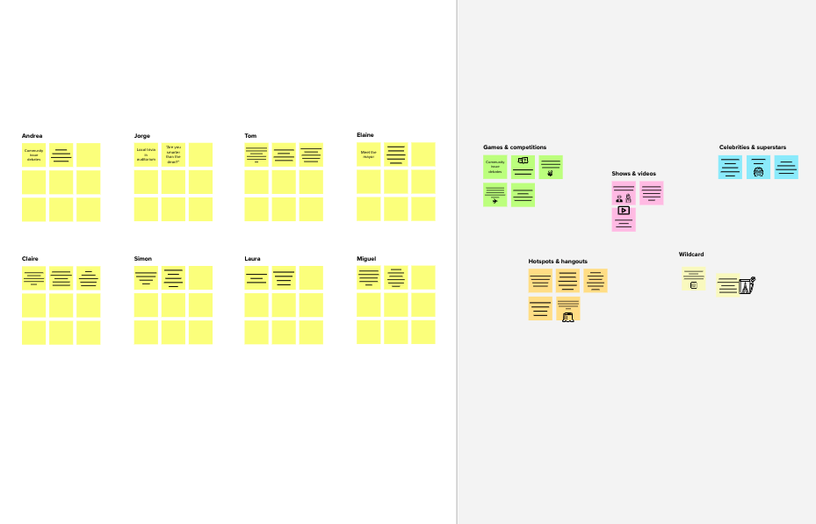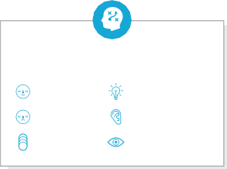

**Template**

**Need some inspiration?**

See a finished version of this template to kickstart your work.

[**Open example**](https://app.mural.co/template/e5a93b7b-49f2-48c9-afd7-a635d860eba6/93f1b98d-b2d2-4695-8e85-7e9c0d2fd9b9)